**Creating Ab/Sub Code for Long Plats and Condos in PACS**

First, you will check the “Abstract Codes” excel sheet to see which code *should* be next available

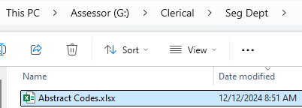

In this case, the last code used was 2061, so the next code we will check is 2062



1. Login to PACS Admin with normal PACS login information

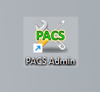

1. In the upper left hand corner, click on “Tools”



1. Then “Code File Maintenance”

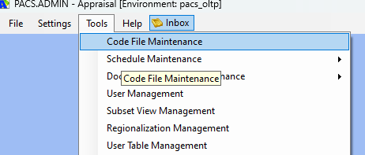

1. Expand the “General” tab

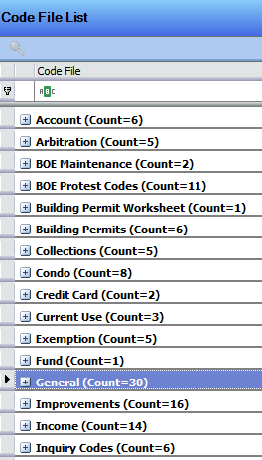

1. Double click on the “Abstract / Subdivision” tab

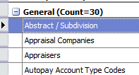

1. Before creating the code, you will make sure the code has not been used in all year layers involved
   1. Circled in yellow – check every year layer involved in this request
   2. Circled in red – type in the code you wish to use

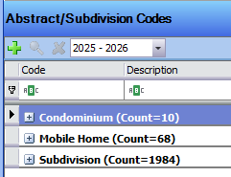

* 1. Circled in green – if the code has been used, you will see a property count under the code
     1. Do NOT use the code if a property count appears in ANY of the year layers. Move on to the next subsequent code and repeat steps to check if it has been used

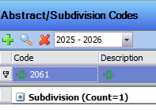

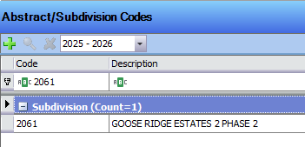

* 1. Circled in purple – if the code has NOT been used, nothing will appear under the code
     1. If all year layers show no property count, you are free to use this code for this request

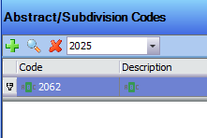

Once you have determined the next code available, you are free to create in all year layers

1. Circled in red – make sure you are in the assessment year for the first year layer that needs to be created
   1. In this case, we are creating year layers 2024/2025 & 2025/2026. Circled is the first assessment year – 2024.

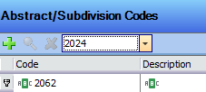

1. click the “green plus”



1. Enter the code you have determined is next and click “OK”

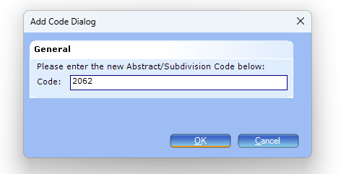

1. Circled in red – make sure you are in the assessment year for the first year layer that needs to be created
   1. In this case, we are creating year layers 2024/2025 & 2025/2026. Circled is the first assessment year – 2024.

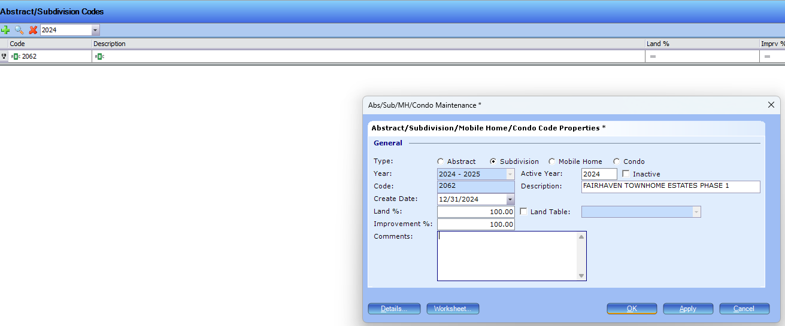

1. Circled in purple – click “subdivision”
   1. Note: if this code is for a condominium, click “condo” instead of “subdivision”

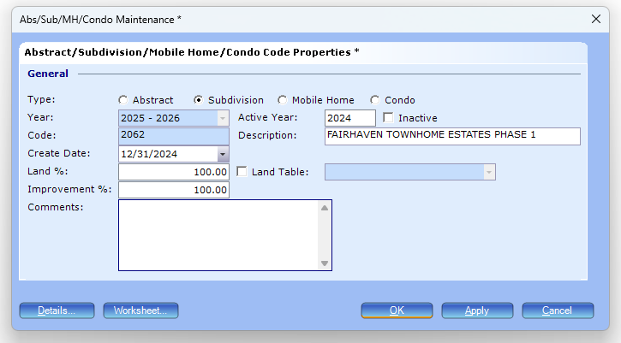

1. Circled in purple – change the date to todays date



1. Circled in purple – type the assessment year in the “Active Year:” spot
   1. This is creating the code for the 2024/2025 year layer so 2024 is entered



1. Circled in purple – type the plat name exactly as it’s written on the plat/email request/excel



1. Circled in purple – click “OK”



You’ll then create the code for the next year layer

1. Circled in red – change the year for the next assessment year that needs to be created
   1. In this case, we are creating year layers 2024/2025 & 2025/2026. Circled is the next assessment year – 2025.

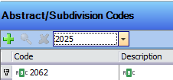

1. click the “green plus”



1. Enter the code you have determined is next and click “OK”



1. Circled in red – make sure you are in the next assessment year that needs to be created
   1. In this case, we are creating year layers 2024/2025 & 2025/2026. Circled is the next assessment year – 2025.

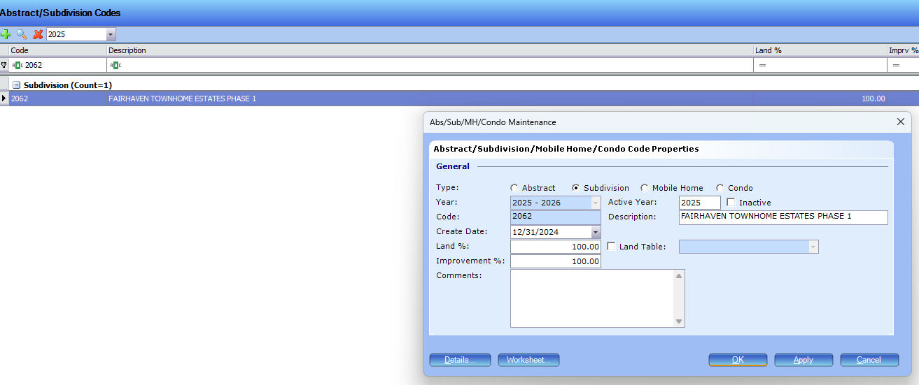

1. Repeat steps 11 through 15, with the exception of the year entered in “Active Year:” – change to the next assessment year (in this case - 2025)

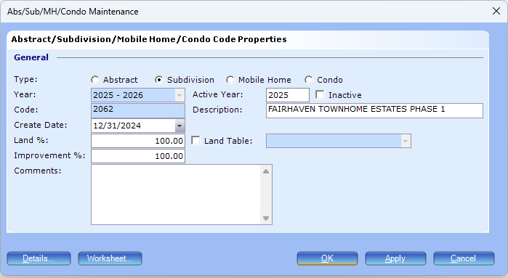

Once you have created the code for all year layers, you are done in PACS Admin  
Input the code in the Abstract Codes.xlsx





Respond to the email request with the created code

